Display Room details

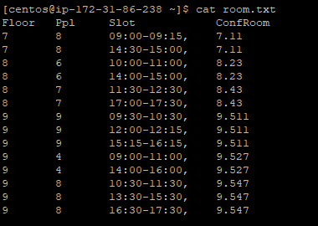

Output:

Please enter parameters as below

Filename followed by ppl floor slot

Example: ./Confroom.sh 8 9 16:30-17:30

Some sample test results:

